Copyright (c) 2020 Hovl Studio (Vladyslav Horobets)

When you purchase this asset, you get a license to use effects, icons with one UI animation, models, textures, scripts, shaders, materials and sounds based on the Unity Asset Store license.

**License does NOT apply to contents of "Demo scene" folder!** It’s also mean that asset support doesn’t apply to animations and scripts that are used in the demo scene, but you can use scripts under the Asset Store license.

**Asset includes:**

26 prefabs (11 complete spells with main and casting effects)  
10 unique icons specially created for this asset  
15 high quality SFX  
“HQ PBR Fantasy staff” asset as addition <https://assetstore.unity.com/packages/slug/121251>

**Using**

**1. Scripts**

1) ZoneTrigger. This script can be used only with Particle System component and collider (trigger). It stop the main effect on trigger enter and Play() another effect.

2) ParticleCollisionInstance. Create prefab(s) on particle collision. It can be used only with Particle System component with enabled check-button “**send collision message**”.

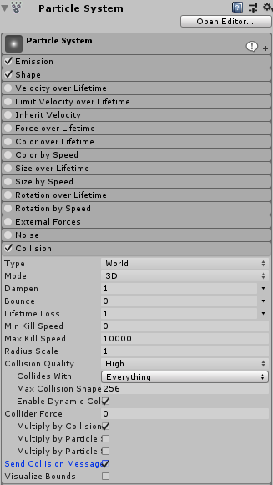

3) FrontAttack. Moves the component and creates prefab effects along the way.  
Check-button “**Play PS**” enable ability to play particle system component and move object instead of moving + creating prefabs.  
“**Pivot**” the parent object on which the effect is returned at the end of "**Spawn Duration**"  
“**Spawn Rate**” is spawn distance between prefabs.  
“**Spawn Duration**” is a prefab spawn time.  
“**Drug**” value 1 means no deceleration, value 0.95 gives small deceleration.  
“**Position Offset**” gives random position offset for spawning prefabs.  
To make a script work, you need to call function “**PrepeareAttack(transform.position)**” from another script, for example:

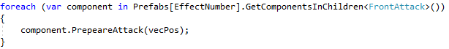  
where “vecPos” is the direction of movement.

5) TargetProjectile. Used for moving object to the target. Automatically deleted when no target. The target is set using another script. Example:



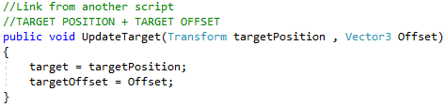

The speed, hit and flash effect(can be null) can be set in this script.

**2. Light**

When using light sources in effects with HDRP, problems may arise on the stage. If you find a bug, you need to remove the light source from effect prefab.

**3. Shaders**

3.1) The "Use depth" on the material from the custom shaders is the Soft Particle Factor.

3.2) Use "Center glow"[MaterialToggle] only with particle system. This option is used to darken the main texture with a white texture (white is visible, black is invisible). If you turn on this feature, you need to use "Custom vertex stream" (Uv0.Custom.xy) in tab "Render". And don't forget to use "Custom data" parameters in your PS.

3.3) The distortion shader only works with standard rendering. Delete (if exist) distortion particles from effects if you use LWRP or HDRP!

3.4) You can change the cutoff in all shaders (except Add_CenterGlow and Blend_CenterGlow) using (Uv0.Custom.xy) in particle system.

**4. Universal Render Pipeline (URP) and High Definition Render Pipeline (HDRP)**

Works only from Unity 2019.2+!

Enable Depth and Opaque Textures in RP settings!

SUPPORT ASSET FOR URP(LWRP) or HDRP here --> <https://assetstore.unity.com/packages/slug/157764>

SUPPORT ASSET FOR URP(LWRP) or HDRP here --> <https://assetstore.unity.com/packages/slug/157764>

SUPPORT ASSET FOR URP(LWRP) or HDRP here --> <https://assetstore.unity.com/packages/slug/157764>

**6. Post Processing**

If you want to use post-effects like in the demo video:

<https://youtu.be/hZSZ2Q8MF3k>

**7. Quality**

For better sparks quality enable "Anisotropic textures: Forced On" in quality settings.

**Support email**

[gorobecn2@gmail.com](mailto:gorobecn2@gmail.com)

P.S. I really need your feedback in the Asset Store because only every 150th buyer leaves the review. Reviews really help sales and can make me add new effects to this asset for free.